Title of Abstract in 14 pt Times
A. B. Author,¹* C. D. Author,² and E. F. Author¹ in 12 pt Times
¹ Department, University, Street Address, City, Country in 12 pt Times
² Department, University, Street Address, City, Country in 12 pt Times
* Corresponding Author: abauthor@uni.edu in 12 pt Times

Please underline the presenter. Insert Abstract here in 12pt Times. Insert Abstract here in 12pt Times. Insert Abstract here in 12pt Times. Insert Abstract here in 12pt Times. Insert Abstract here in 12pt Times. Insert Abstract here in 12pt Times. Insert Abstract here in 12pt Times. Insert Abstract here in 12pt Times. Insert Abstract here in 12pt Times. Insert Abstract here in 12pt Times. Insert Abstract here in 12pt Times.
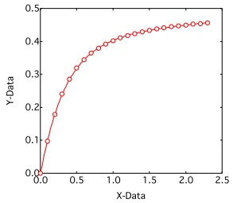

Figure 1. Plot of Y-Data as a function of X-Data in 10 pt Times

References
[1] A.Author#1, A.Author#2, A.Author#3, et al., Journal, vol, page numbers (year) in 10 pt Times
[2] A.Author#1, A.Author#2, A.Author#3, et al., Journal, vol, page numbers (year) in 10 pt Times
[3] A.Author#1, A.Author#2, A.Author#3, et al., Journal, vol, page numbers (year) in 10 pt Times
Note: Abstract is only one page.
(Of course, exceptions can be made, so please consult with us if necessary. )

